University of Phoenix Material

Cell Division, Chromosomes, and Inheritance Worksheet

Complete all four sections of this worksheet.

Section I: Mitosis and Meiosis

Part 1: Review the following images on mitosis and meiosis.

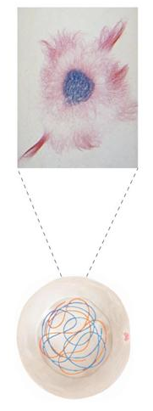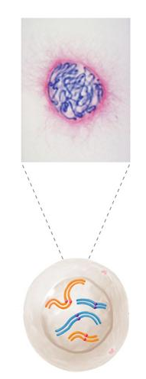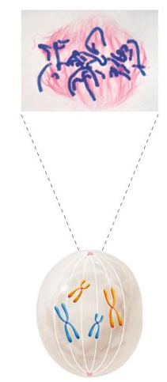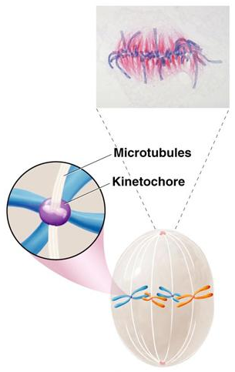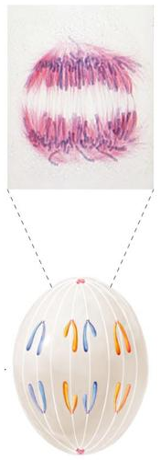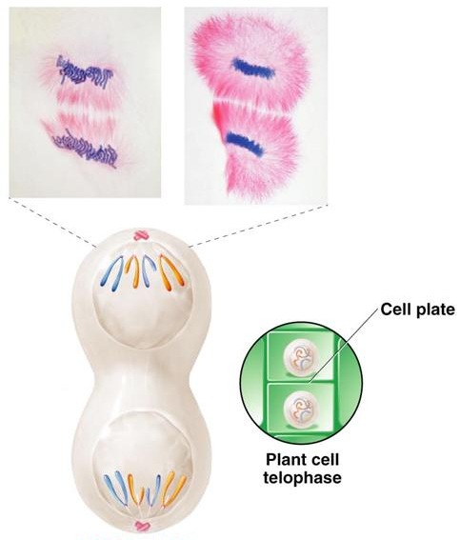

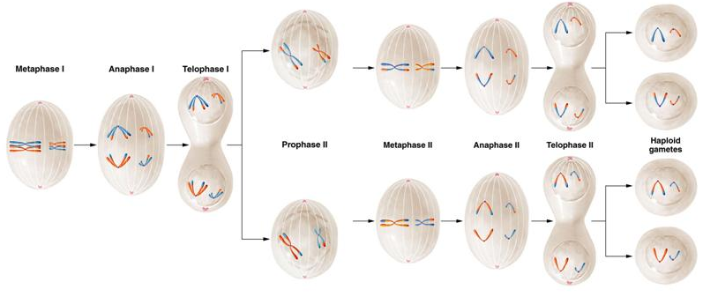
Part 2: Explain the events you observe in the pictures.

Part 3: Identify similarities and differences between the pictures you described. Use drawing tools to indicate similarities and differences, where possible.

Section II: Genetic Diversity

Briefly describe the following events and explain their role in creating genetic diversity:

- Proteins: Proteins are made up of amino acids. They create genetic diversity because there are twenty different amino acids that can make up a protein molecule that form polypeptide chains.

- Crossing over: Crossing over occurs during meiosis. The exchange of the chromosomes during crossing over offers a lot of genetic variation.

- Independent assortment: Independent assortment is two genes that separate to two different chromosomes. This is why we look different from our siblings.

- Mutation: Mutation is when a mutant allele has modified genetic information and alters the gene product. This creates genetic diversity because someone with a certain mutant gene can look completely different from everyone else.

Section III: Mendelian Genetics

Post your answers to the following questions from the Problems and Discussion Questions section at the end of Ch. 3 of Concepts of Genetics:

Question 7:

With regard to the ABO blood types in humans, determine the genotype of the male parent and female parent shown here:
Male parent: Blood type B; mother type O
Female parent: Blood type A; father type B
Predict the blood types of the offspring that this couple may have and the expected proportion of each.

Male Parent Genotype: BO
Female Parent Genotype: AO

AO BO

AO AO AB

BO BO OO

¼ AB, ¼ BO, ¼ AO ¼ OO
Ratio: 1:1:1:1

Question 16:

Mendel crossed peas having round green seeds with peas having wrinkled yellow seeds. All F1 plants had seeds that were round and yellow. Predict the results of testcrossing these F1 plants.

Green/round X yellow/wrinkled = yellow/round

ggWW X GGww

gW X Gw= GgWw

F1= GgWw

F1XF1

GW Gw gW gw
GW GGWW GGWw GgWW GgWw
YellowRound YellowRound YellowRound YellowRound

Gw GGwW GGww GgwW Ggww
YellowRound YellowW YellowRound yellow,wrinkled

gW gGWW GgWw ggWW ggWw
YellowRound YellowRound greenround greenround

Gw GGWw GGww GgwW Ggww
YellowRound yellowWrinkled greenRound greenWrinkled

You will have: 9/16 yellow round
3/16 yellow wrinkled
3/16 green round
1/16 green, wrinkled

Section IV: Chromosomes

Write 1 to 2 paragraphs explaining the role chromosomes play in heredity. Include the structure and function of chromosomes.

